BUATLAH PEMROGRAMN BERORIENTASI OBJEK DENGAN KONSEP INHERITANCE DAN POLIMORPHISME STUDI KASUS : SEKOLAH

Perhatikan Gambar di bawah ini sebagai panduan untu membuat objek dan atribut!

# nama : String

+ Sekolah ()

+ info() : void

Rumus

Siswa

Guru

Sekolah

+ getNilaiAkhir() : Double

+ getNilaiRerata(Siswa a[])

: double

Inheritance

Interface

- nip : int

- mapel : String

+ Guru ()

+ setDataGuru():void

+ getNip() : int

+ getNama() : String

+ getMapel() : String

+ info() : void

paketA

Sekolah Guru Siswa

Uji Sekolah

UjiSekolah

+ main()

paketB Rumus

* nis : int
* uts : int
* uas : int

+ Siswa ()

+ InputDataSiswa():void

+ getNis() : int

+ getNama() : String

+ getUts() : int

+ getUas() : int

+ getNilaiAkhir() : Double

+ getNilaiRerata(Siswa a[]) : double

+ getNilaiHuruf() : String

+ info() : void

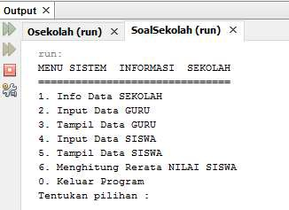Buatlah Tampilan Awal main seperti Gambar dibawah ini !

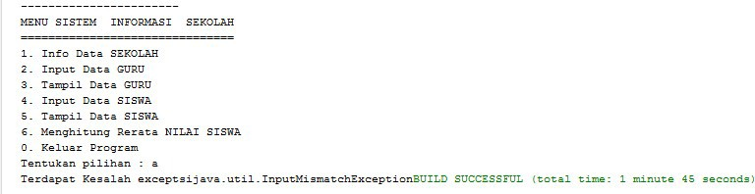Buatlah exception jika pilihan tidak sesuai muncul message :

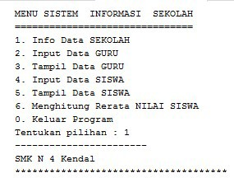Tampilan menu 1

Tampilan dari Data Guru

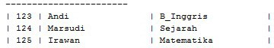

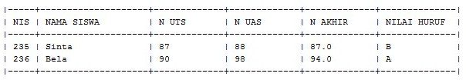Tampilan Data Siswa

**KUNCI JAWABAN**

package paketA;

/**

*

* @author Zaenuri

*/

public class Sekolah { protected String nama; Sekolah(){}

public void info(){ System.out.println("SMK N 4 Kendal");

}

}

package paketA;

import java.util.Scanner;

/**

*

* @author AZ

*/

public class Guru extends Sekolah { private int NIP;

private String mapel; Guru(){}

public void setDataGuru(){

Scanner baca=new Scanner(System.in); System.out.print("input NIP :");this.NIP=baca.nextInt();

System.out.print("input Nama Guru :");this.nama=baca.next(); System.out.print("Input Mata Pelajaran :");this.mapel=baca.next();

}

public int getNIP(){ return NIP ;

}

public String getNama(){ return nama;

}

public String getMapel(){ return mapel;

}

public void infoGuru(){

System.out.println(String.format("%1$-5s %2$-20s %3$-20s %4$-2s","| "+getNIP(),"| "+getNama(),"| "+getMapel()," |"));

}

}

package paketA;

/**

* @author Zaenuri

*/

import java.util.Scanner; import paketB.Rumus;

public class Siswa extends Sekolah implements Rumus { private int NIS,UAS,UTS;

Siswa(){

}

public void inputDataSiswa(){

Scanner baca=new Scanner(System.in); System.out.print("Inputkan NIS : ");NIS=baca.nextInt(); System.out.print("Inputkan Nama Siswa : ");nama=baca.next(); System.out.print("Inputkan NUTS : ");UTS=baca.nextInt(); System.out.print("Inputkan NUAS : ");UAS=baca.nextInt()

}

public int getNIS(){ return NIS;

}

public String getNama(){ return nama;

}

public int getUTS(){ return UTS;

}

public int getUAS(){ return UAS;

}

@Override

public double getNilAkhir(){

double nilAkhir=(getUTS()+getUAS())/2; return nilAkhir;

}

@Override

public double getAverage(Siswa a[]){ double rerata, jml=0;

for(int i=0;i<a.length;i++){ jml=jml+getNilAkhir();

}

rerata=jml/a.length; return rerata;

}

@Override

public void sortASC(Siswa a[]){ int n=a.length;

double NA[] = new double[n]; double temp;

for(int i=0;i<n;i++){

NA[i] = a[i].getNilAkhir();

}

for(int x=0; x<n; x++){ for(int z=0; z>n-1; z++){

if(NA[z]<NA[z+1]){

temp=NA[z]; NA[z]=NA[z+1];

NA[z-1]=temp;

}

}

}

System.out.println("Data Nilai Setelah Di Urutkan"); System.out.println(" ");

for(int y=0;y<n;y++){ System.out.println("| "+NA[y]+" +");

}

}

public String getNilHuruf(){ String NilHuruf;

if(getNilAkhir()>=90)NilHuruf="A";else if(getNilAkhir()>=80)NilHuruf="B";else if(getNilAkhir()>=70)NilHuruf="C";else if(getNilAkhir()>=60)NilHuruf="D";else if(getNilAkhir()>=50)NilHuruf="E";else

NilHuruf="F"; return NilHuruf;

}

@Override

public void searching(Siswa b[]){

Scanner baca= new Scanner(System.in); double min,max;

System.out.print("Nilai Minimum :");min=baca.nextDouble(); System.out.print("Nilai Maximum :");max=baca.nextDouble(); for(int i=0;i<b.length;i++){

if(b[i].getNilAkhir()>min && b[i].getNilAkhir()<max){ b[i].info();

}

}

}

@Override

public void info(){

System.out.println(String.format("%1$-5s %2$-20s %3$-13s %4$-13s %5$-13s %6$-13s %7$-2s",

"| "+getNIS(),"| "+getNama(),"| "+getUTS(),"| "+getUAS(),"| "+getNilAkhir(),"| "+getNilHuruf()," |"));

}

}

package paketA;

/**

*

* @author Zaenuri

*/

import java.util.InputMismatchException; import java.util.Scanner;

public class ujiSekolah {

public static void main(String[]args){ boolean kondisi = true;

int pil;

Sekolah v_Sek=new Sekolah(); Guru gur[]=new Guru[3]; Siswa sis[]=new Siswa[3];

Scanner baca=new Scanner(System.in); try{

while (kondisi){

System.out.println("MENU SISTEM INFORMASI SEKOLAH"); System.out.println("===============================");

System.out.println("1. Input Data SEKOLAH"); System.out.println("2. Input Data GURU"); System.out.println("3. Tampil Data GURU"); System.out.println("4. Input Data SISWA"); System.out.println("5. Tampil Data SISWA"); System.out.println("6. Menghitung Rerata NILAI SISWA"); System.out.println("0. Keluar Program"); System.out.print("Tentukan pilihan : ");pil = baca.nextInt(); System.out.println(" ");

switch (pil) { case 1:{

v_Sek.info(); System.out.println("***************************************************"); break;

}

case 2:{

for(int i=0;i<gur.length;i++){ gur[i]= new Guru(); gur[i].setDataGuru();

}

break;

}

case 3:{

for(int i=0;i<gur.length;i++){ gur[i].infoGuru();

}

break;

}

case 4:{

for(int i=0;i<sis.length;i++){ sis[i]=new Siswa(); sis[i].inputDataSiswa();

}

break;

}

case 5:{ System.out.println("| +

+ + + +

|");

System.out.println(String.format("%1$-5s %2$-20s %3$-13s %4$-13s %5$-13s %6$-13s %7$-2s", "| NIS","| NAMA SISWA","| N UTS","| N UAS","| N AKHIR","| NILAI HURUF"," |"));

System.out.println("| +

+ + + +

|");

for(int i=0;i<sis.length;i++){

//sis[i]=new Siswa(); sis[i].info();

}

System.out.println("| + break;

}

+ + + +

|");

case 6:{

double rata2=sis[1].getAverage(sis); System.out.println("Rata Nili Kelas : "+rata2); break;

}

case 0:{ kondisi=false; break;

}

}

}

}catch(InputMismatchException e){ System.out.print("Terdpat Kesalah exceptsi" + e);

}

}

}

package paketB;

/**

*

* @author Zaenuri

*/

import paketA.Siswa; public interface Rumus {

public double getNilAkhir(); public void sortASC(Siswa a[]);

/**

*

* + @param a
  + @return

*/

public double getAverage(Siswa a[]); public void searching(Siswa b[]);

}